Siemens PLC.

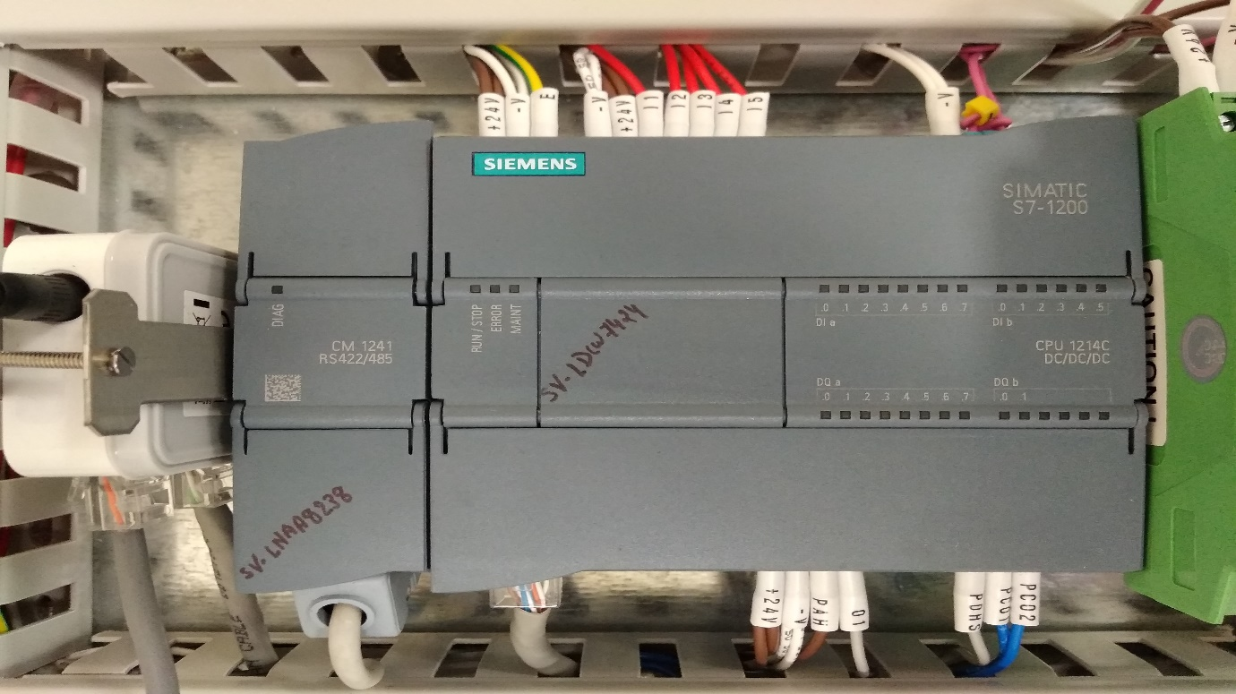

Open Cover. Memory Card Slot.

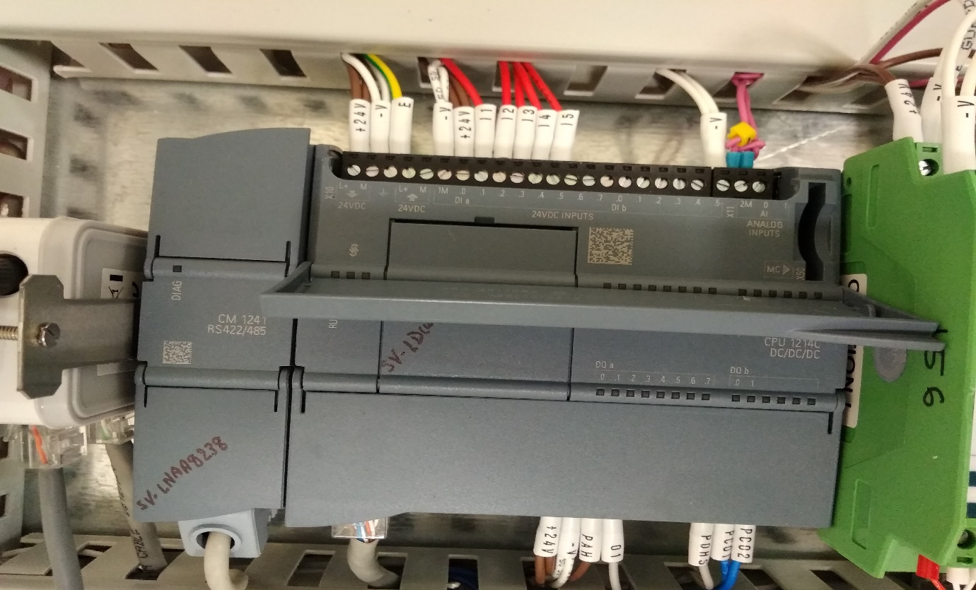

Insert Memory Card.(Only Siemens Memory card will support)

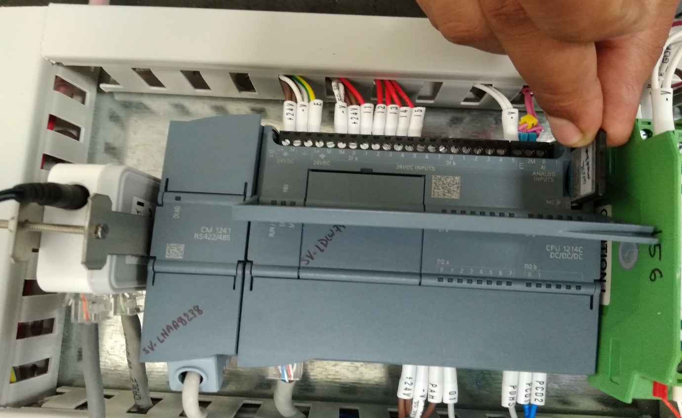

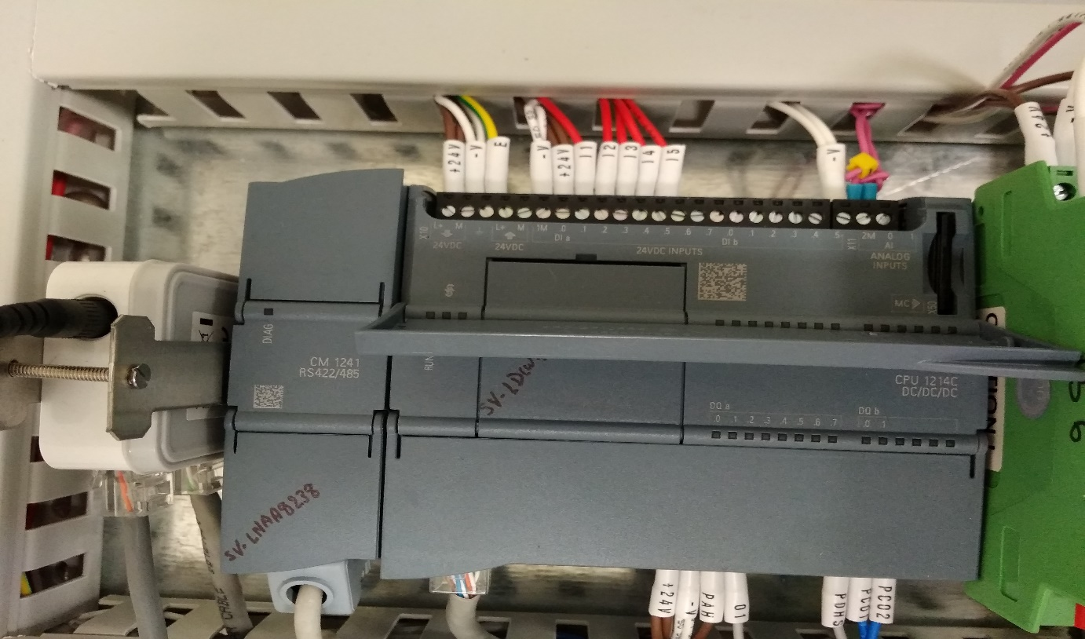

Close Cover and switch ON UPS supply.

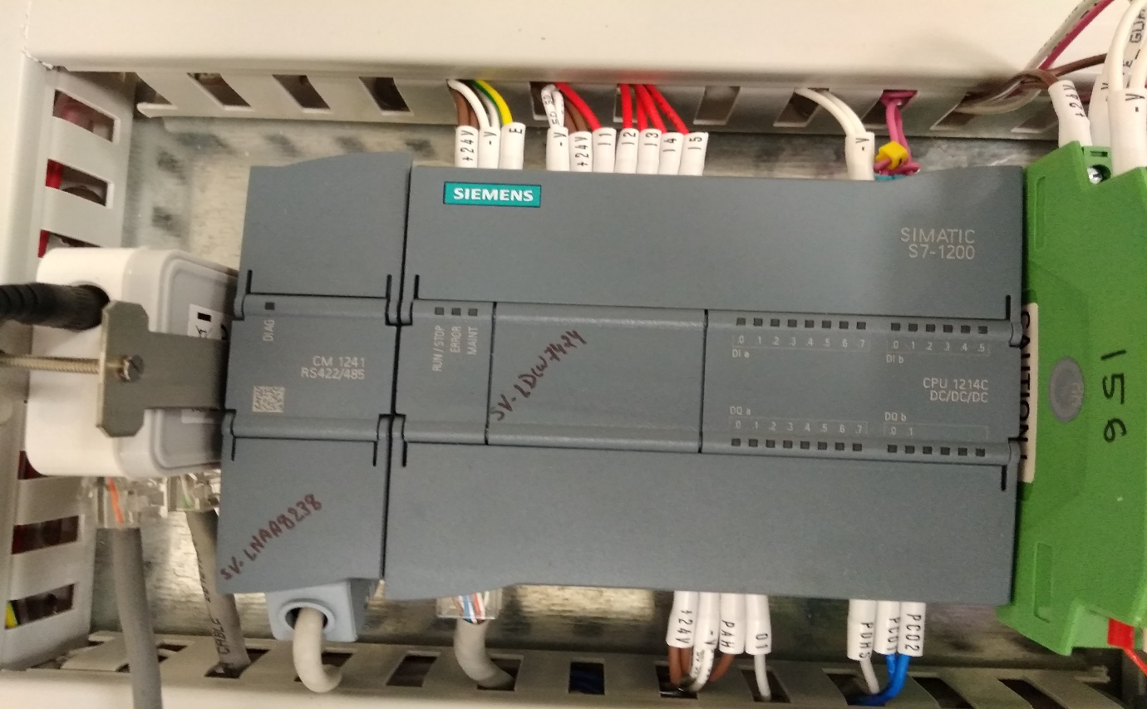

Once UPS supply is ON Automatically Program is start to download.

While programming **Run/stop, Error and Maint** indication will start to blinking.

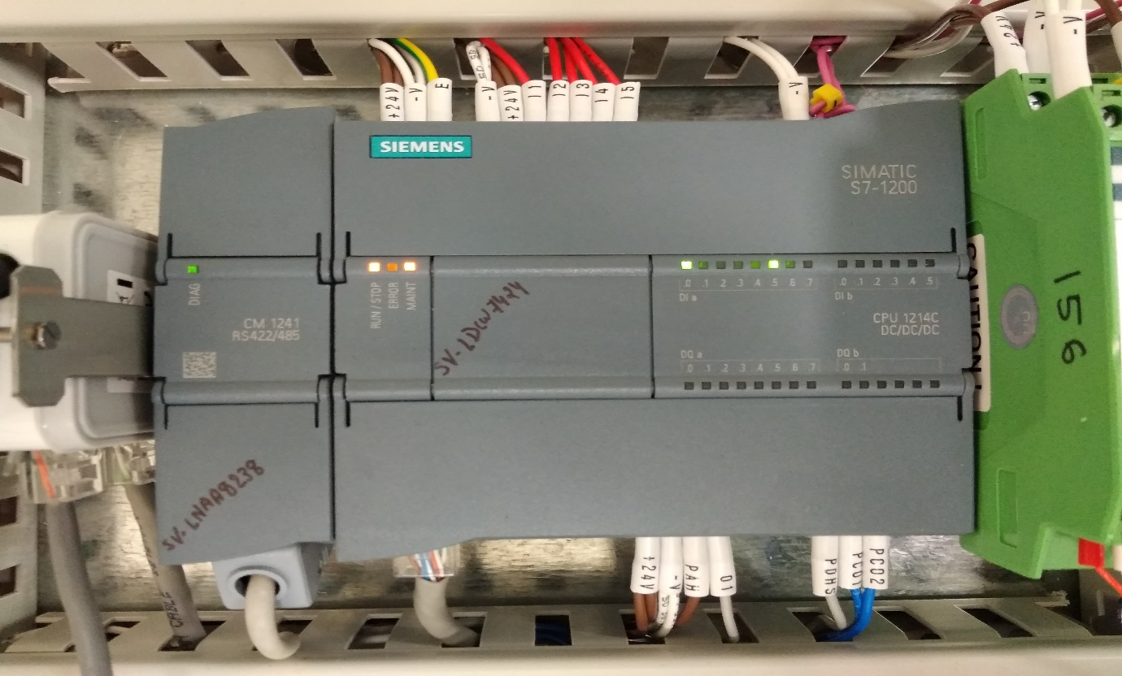

Once Program is done Run/stop Indication showing Green and steady.

