Cooling Incubator INPUT/OUTPUT Connection.

|  |  |  |  |
| --- | --- | --- | --- |
| **INPUT CONNECTION** | | | |
| SR.No. | Identification Ferule | Supply | Description. |
| 01 | +24V | +24V |  |
| 02 | -V | -V |  |
| 03 | E | E |  |
| 04 | -V |  | Stand By Compressor Feed back |
| 05 | +24V |  |  |
| 06 | I2 | +24V | Compressor No. 01 Feed back |
| 07 | I3 | +24V | Compressor No. 02 Feed back |
| 08 | I4 | +24V | Mains Feed back |
| 09 | I5 | +24V | Door Switch Feed back |
| 10 | -V |  |  |
| 11 | 1 |  | Temperature Sensor no. 01 |
| **OUTPUT CONNECTION** | | | |
| 01 | +24V | +24V |  |
| 02 | -V | -V |  |
| 03 | PAH | +24V | PLC Alarm Hooter |
| 04 | PDO-H | +24V | PLC Door Heater |
| 05 | PCO1 | +24V | PLC Compressor No. 01 |
| 06 | PCO2 | +24V | PLC Compressor No. 02 |

**Transit Relay Card.**

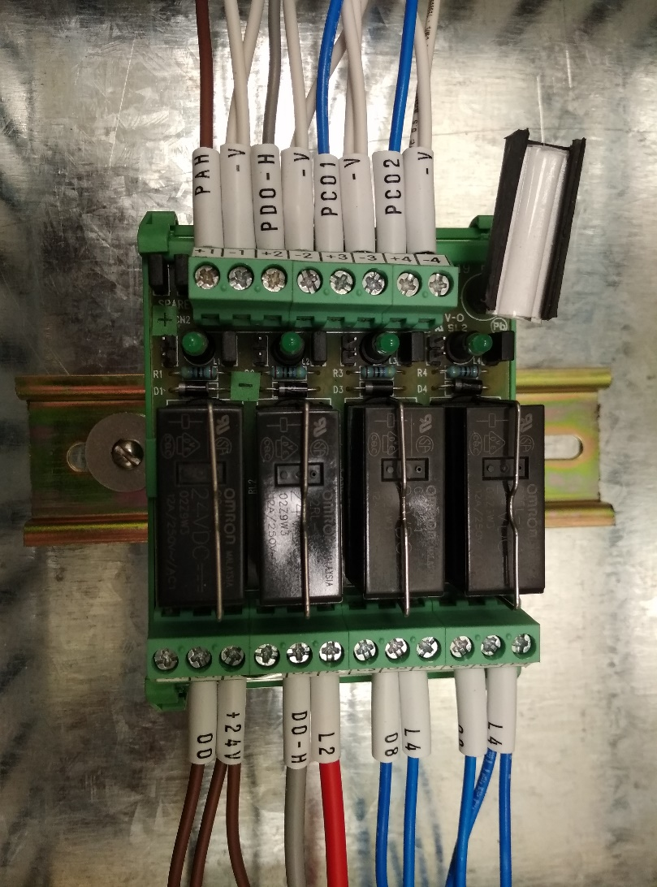

|  |  |  |  |  |
| --- | --- | --- | --- | --- |
| 01 | -V | -V |  | All Wires Coming from PLC Output. (Starting with **P**) |
| 02 | PCO2 | +24V | PLC COMPRESSOR 02 |
| 03 | -V | -V |  |
| 04 | PCO1 | +24V | PLC COMPRESSOR 01 |
| 05 | -V | -V |  |
| 06 | PDO-H | +24V | PLC DOOR HEATER |
| 07 | -V | -V |  |
| 08 | PAH | +24V | PLC ALARM HOOTER |

|  |  |  |  |  |
| --- | --- | --- | --- | --- |
| 01 | L4 | 230 V AC |  | All Wires Going to Relay/contactor/terminals.  Transit Relay card is only **5Amps**.DO not connect heavy components directly on the Card. |
| 02 | 09 | 230 V AC | Compressor 02 Output 230 V AC |
| 03 | L4 | 230 V AC |  |
| 04 | 08 | 230 V AC | Compressor 02 Output 230 V AC |
| 05 | L2 | 230 V AC |  |
| 06 | DO-H | 230 V AC | Door Heater Output 230 V AC |
| 07 | +24V | +24V |  |
| 08 | 00 | +24V | Alarm Hooter Output +24V |