**How to Keep PLC in Remote mode for Online Programming?**

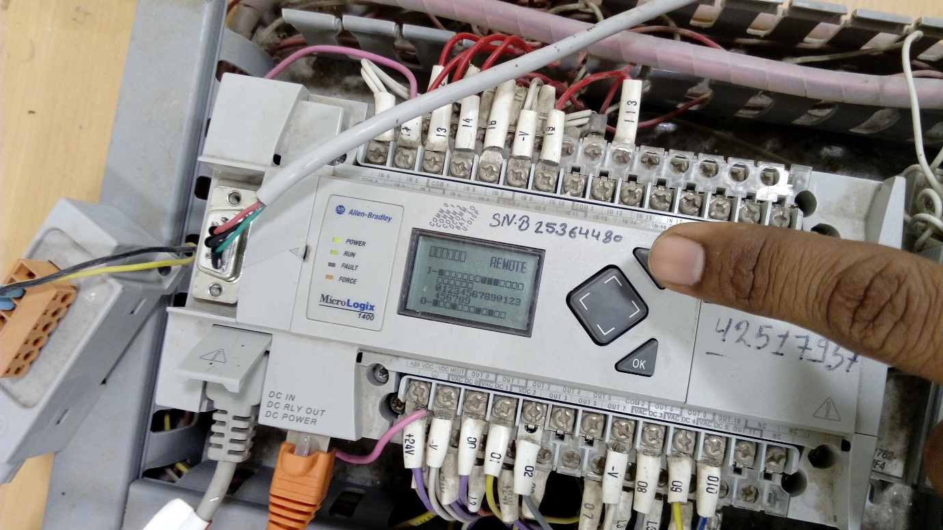

Press ESC.

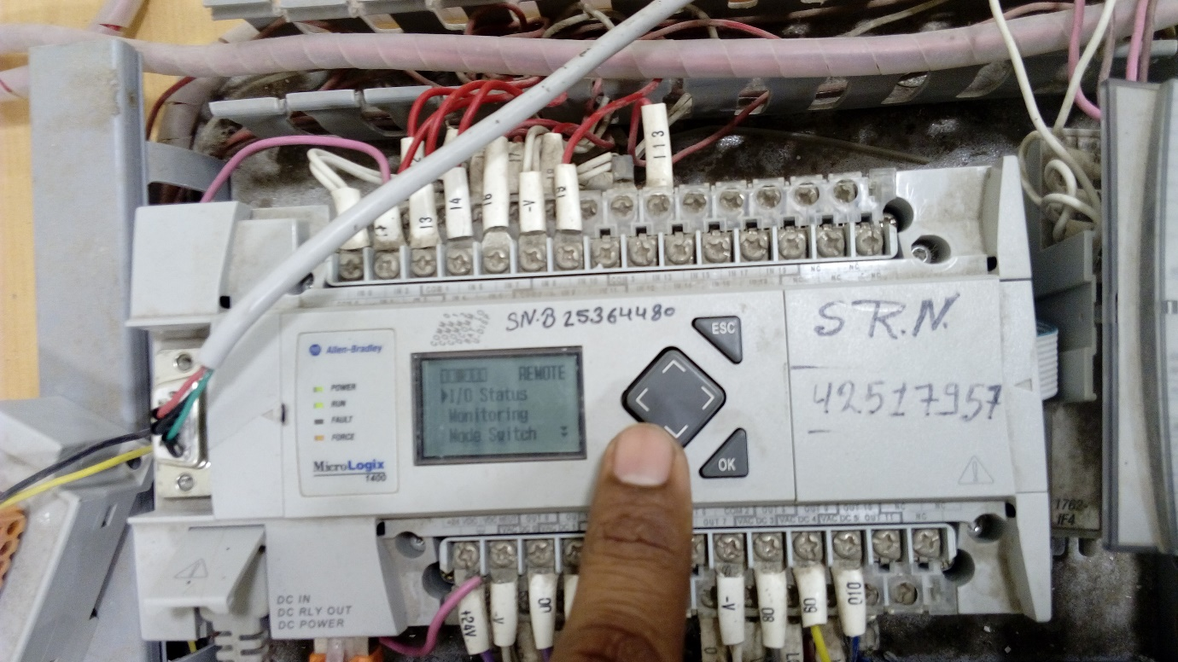

Press Down key and select Mode switch.

Press OK.

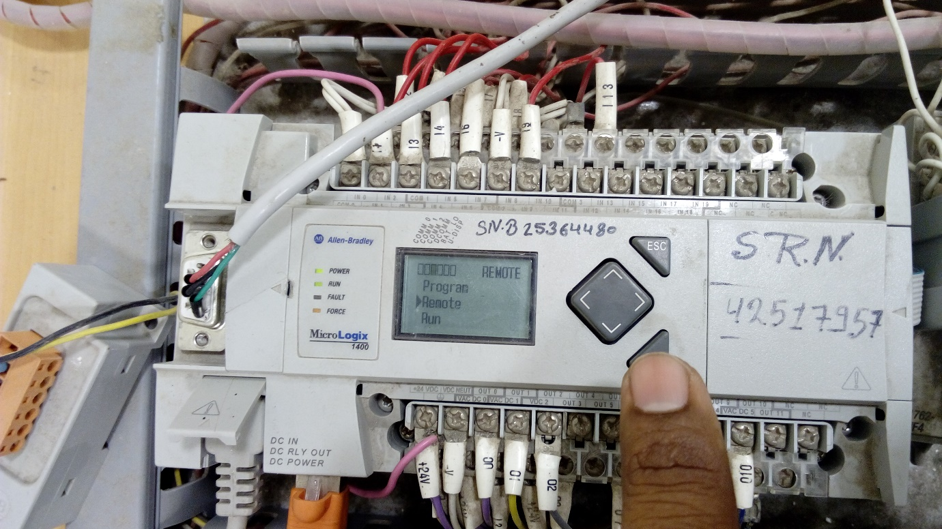

Select Remote and Press OK.