**Vaisala Sensor ID Procedure.**

Run The Vaisala software setup for USB cable communication.

Connect the Sensor with USB cable and connect USB to Computer.

Check the com port no. from Device Manager.

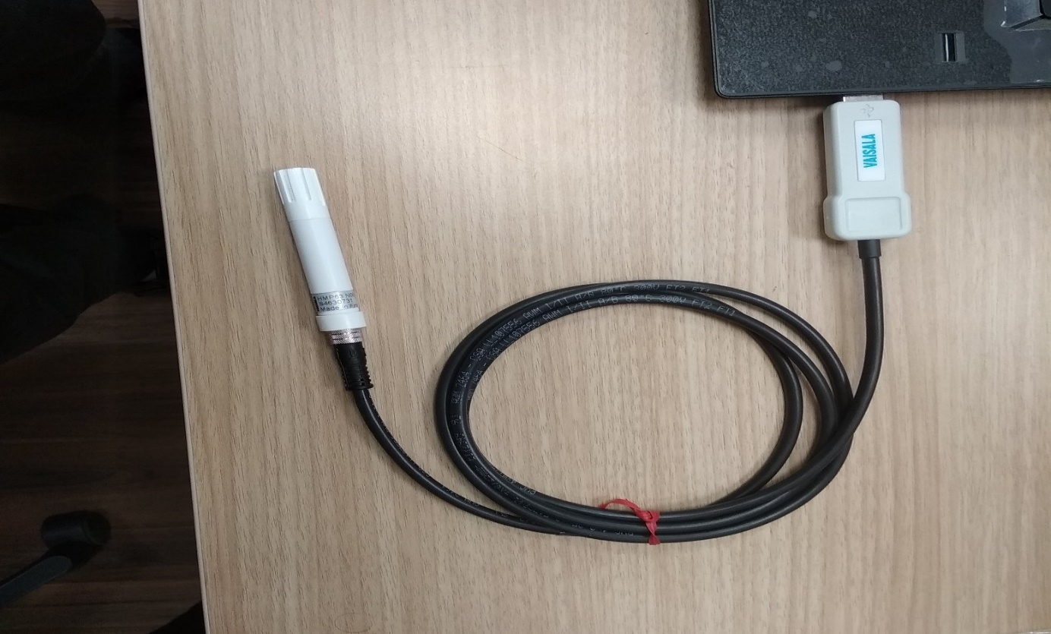

Open Vaisala application folder.

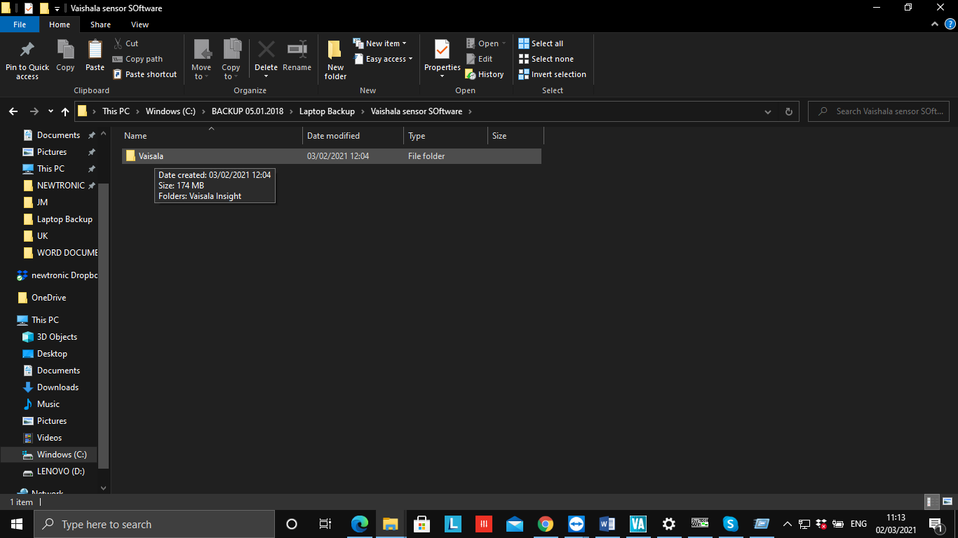

Run **Insight_server** Application.

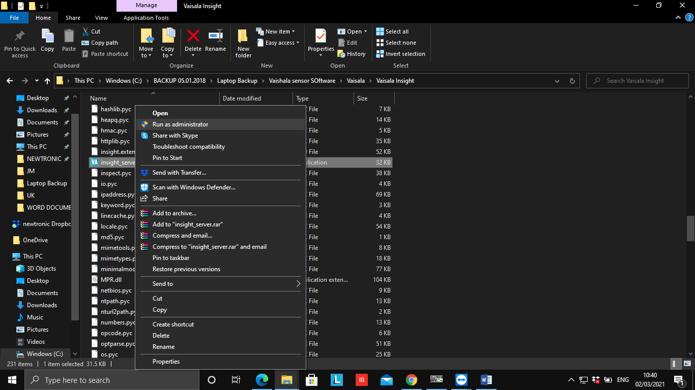

Application will open and Connected sensor is showing current Temp. and Humidity Values.

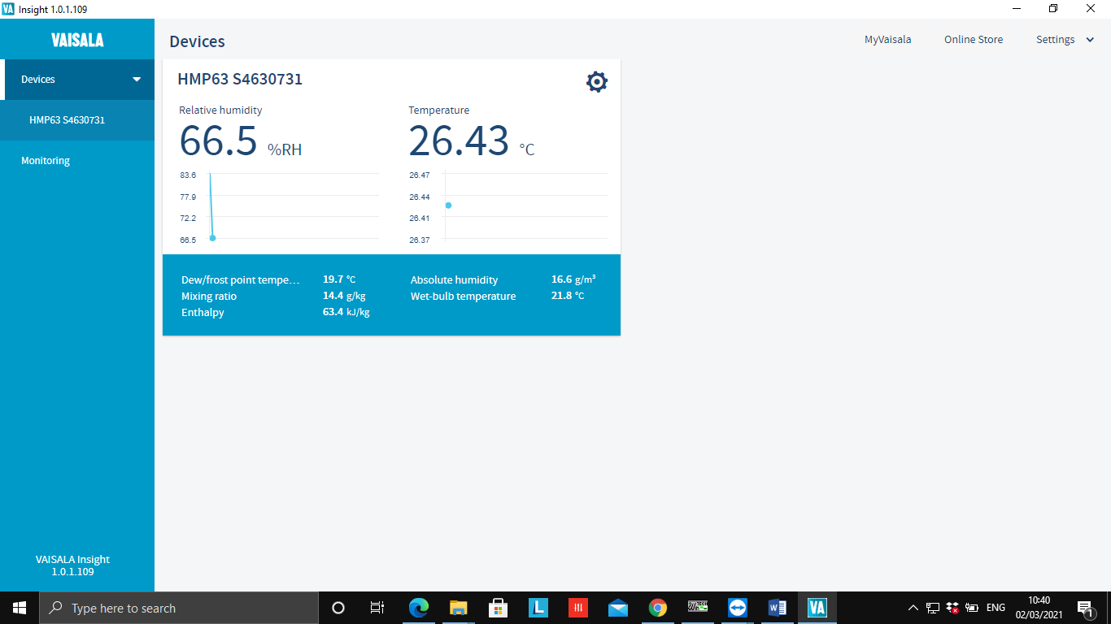

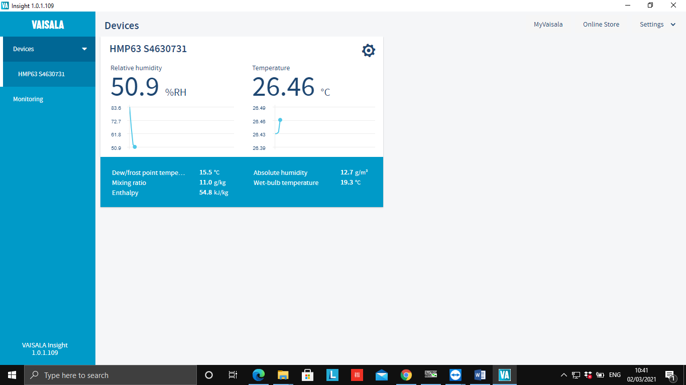

Click Here.

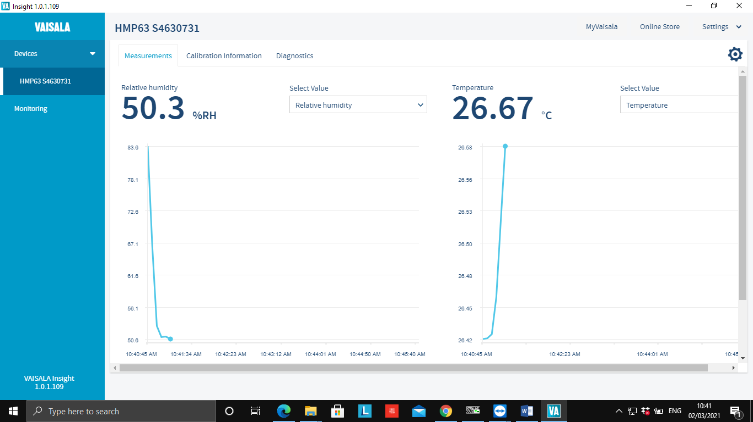

Click on settings option.

Click on Configure Device.

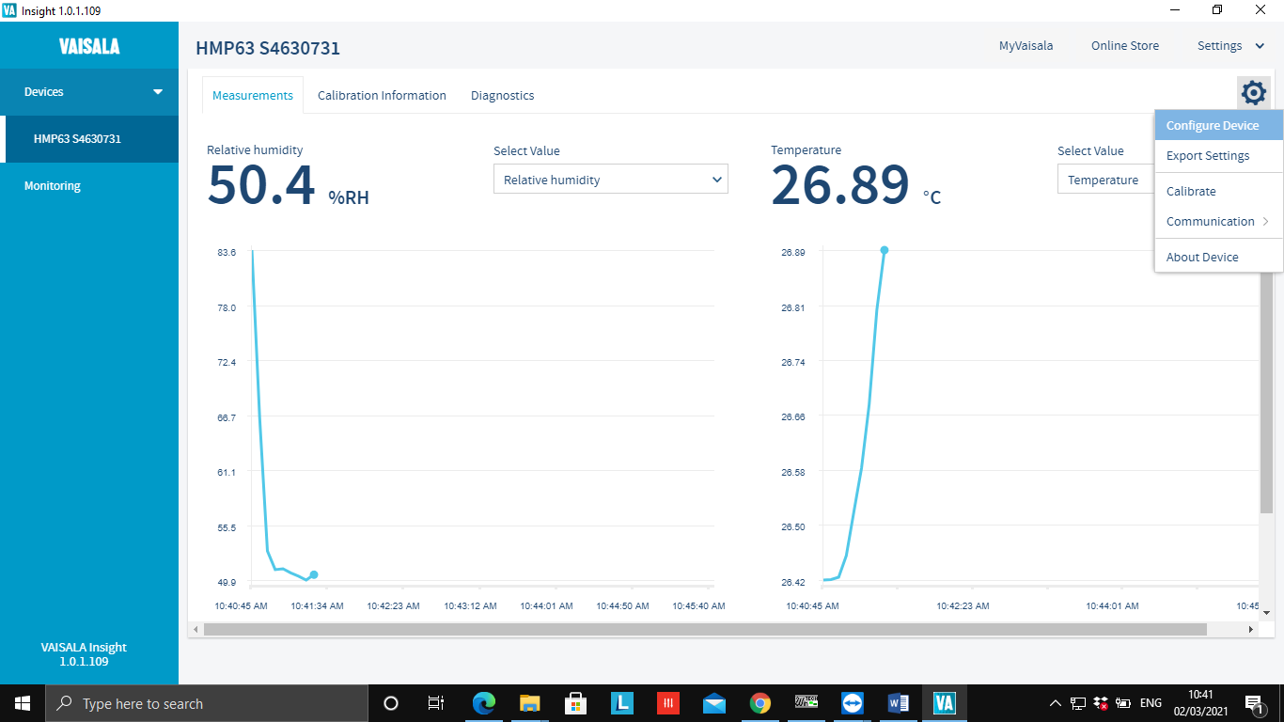

Click on Communication Device.

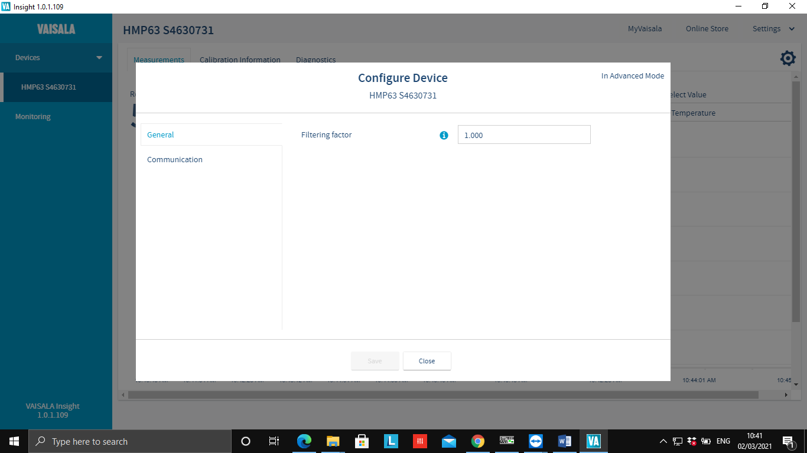

Communication Window will open.

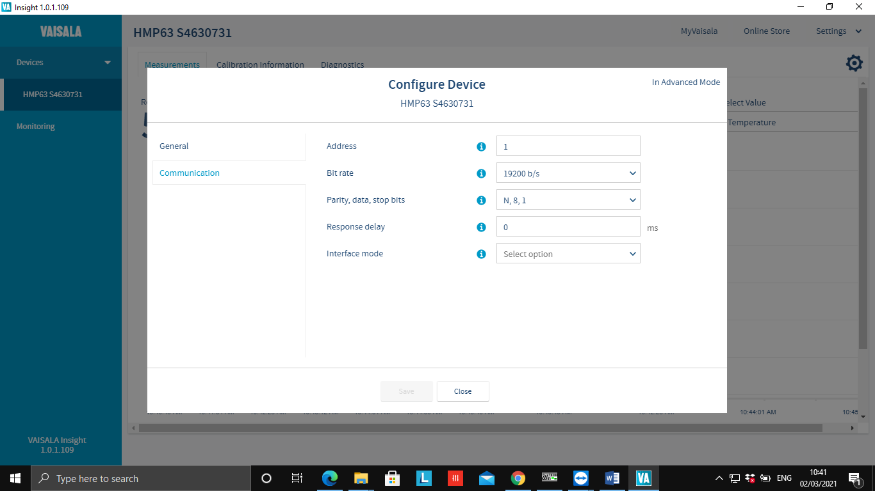

Put Required sensor ID no. in Address option.

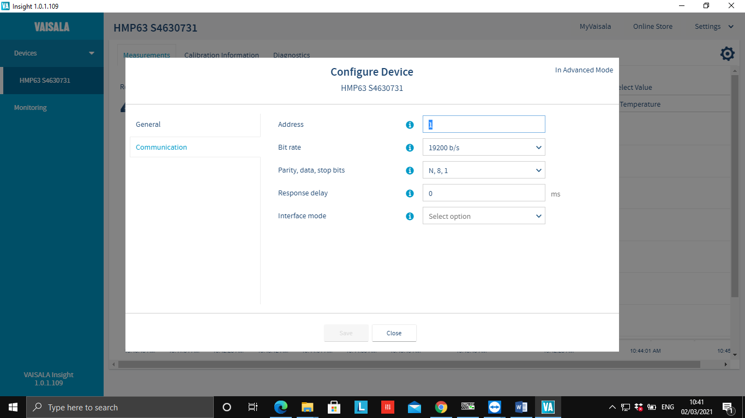

|  |  |
| --- | --- |
| Given ID | Sensor Showing On HMI (On Scanner) |
| 1 | 3 |
| 2 | 4 |
| 3 | 5 |
| 4 | 6 |
| 5 | 7 |
| 6 | 8 |

Click on Save Option.

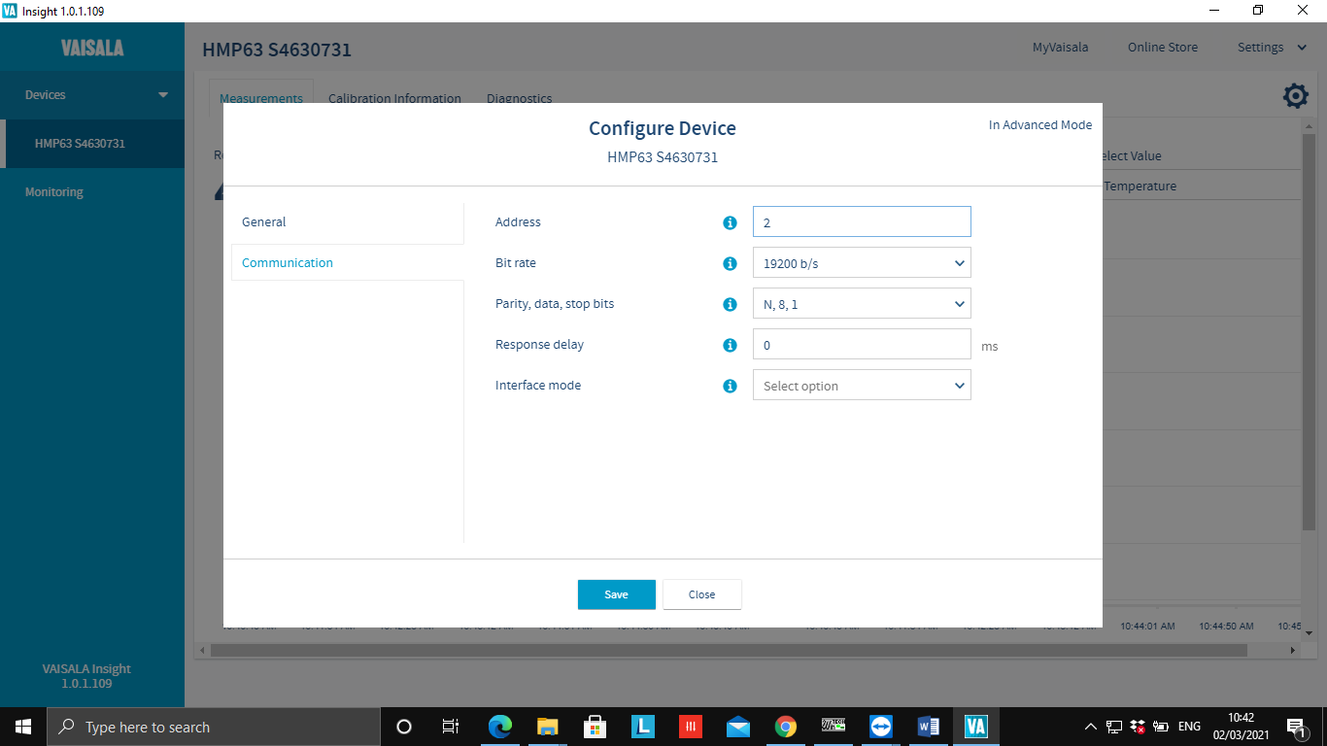

Click on Close.

